Lab 08: Setup JUnit

Objective
This lab will help you become familiar with some of the new testing features of the Eclipse. Specifically, we will look at how to:

1. Create and run a JUnit 4 Test Case.

Step by Step Guide

Step by Step Instructions

Before starting this lab exercise, your instructor will demonstrate the key features of the IDE that will be used for this class. A how-to document is also available in your course book if you are unfamiliar with the IDE being used. Please review that document before beginning the lab exercise.

Add a new project
- Create a new Project in your workspace named TDDExerciser.
- Add a new package to the project named com.lq.testcases
- In the package, open the New Wizard by selecting File > Other
- When the New Wizard appears, enter “JU” in the Wizards field—upper or lower case is fine. This will constrain the view to show only those wizards that start with the letters “JU.” The wizard should appear as follows:

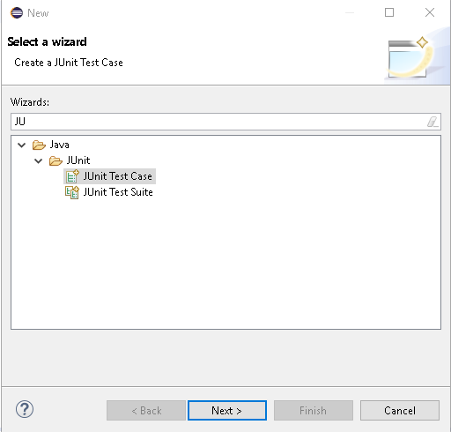

- Select Java project using the arrow keys or mouse, and click Next. You should see the Java Project Wizard appear as seen below:

Create a Class to Test and a JUnit 4 Test Class

- In the Package Explorer view, expand the project by clicking on the to the left of the project name. Right click on the project source folder (src) and select New > Other from the pop-up menu.

- Enter “JU” (upper or lower case) into the Wizards field – you should now see the following:

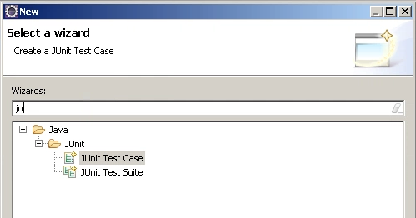

- Select JUnit Test Case, and click Next. Click the new JUnit 4 test radio button, and enter a package name of com.lq.testcases and class name of MyFirstTestCase. Leave all other fields and checkboxes as they are as none are needed. Click Finish. The JUnit Test Case wizard should appear as below:

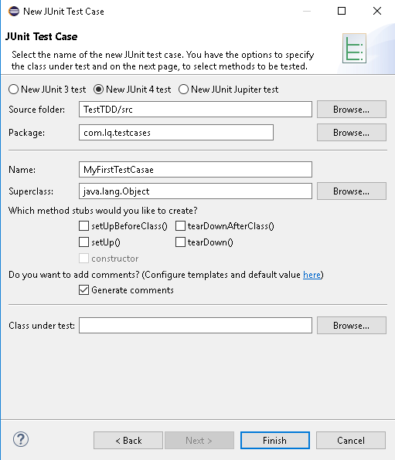

- Click OK to add the JUnit 4 library to the build path.

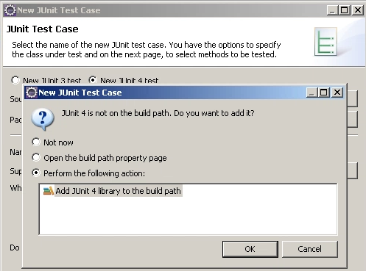

- You should now see the following:

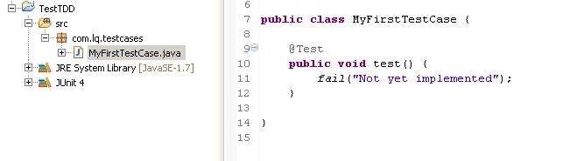

- Right-click on the src folder, and again select New > CLASS.

- You should now see the New Java Class wizard:

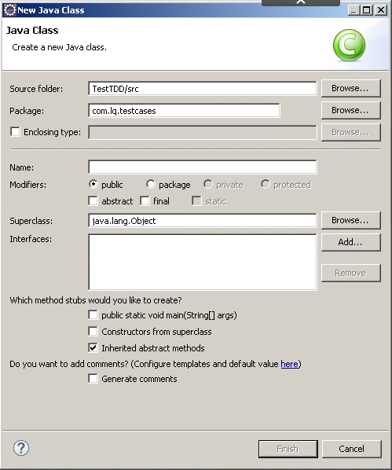

- Enter a package name of com.lq.testclasses and class name of ClassToTest. Click Finish. You should now see the following:

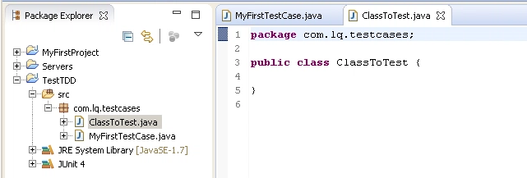

- Be sure to save your work on a regular basis: press control + shift + s to save all modified resources.

Implement the Method to Test and the Test Methods

- In the ClassToTest, create a single method named methodToTest, which returns a value of Boolean true.

- In MyFirstTestcase, add the following code to implement the test case:

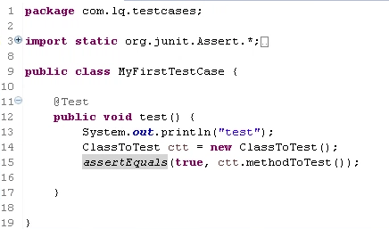

- Save your changes, and then right-click on MyFirstTestcase in the Package Explorer view, and select Run as > JUnit Test.

- Look for two things: in the Console view, you should see “testMethod” from the message sent to sysout, and, secondly, you should see the appearance of a new view—the JUnit view, which should look as follows:

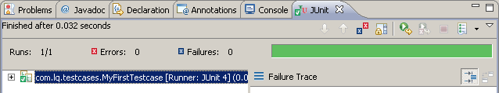

- Notice the green checkbox in the view; this indicates that the test case ran successfully.

- Change the return value of methodToTest to boolean false. Run the test once again. You should now see the following:

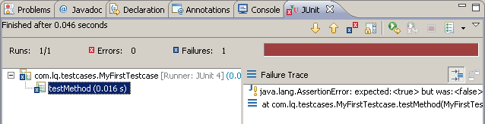

- This time, we see that the test has failed. Notice that as you expand the view of the test case in the JUnit view, you see displayed all failed test methods and the amount of time the test took to run.

